# How to create a Java Project in your Git Repository

1. Go to github.com
2. Login with your valid credentials
3. Create a repository any valid name. (Please do not give spaces)

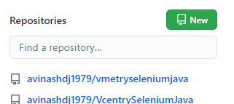

1. Click on New Button

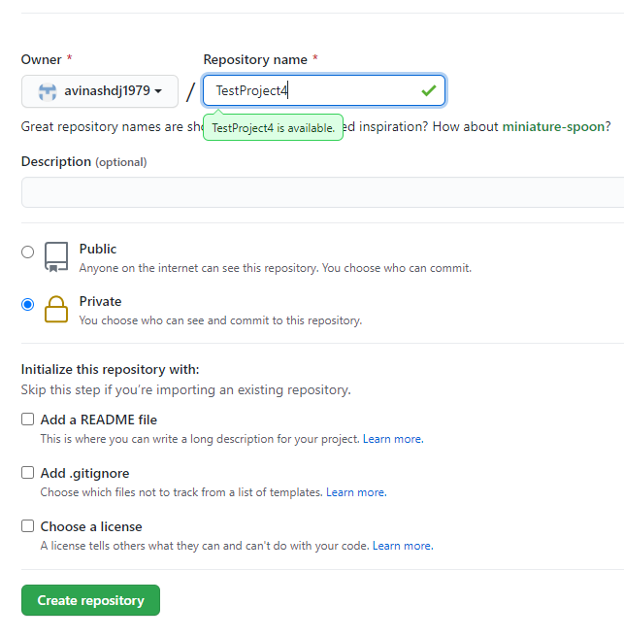

1. Enter a valid name and select private (if you are not intending to share with others)
2. Click on Create Repository
3. Repository gets successfully created.
4. Open Eclipse,
5. Create a New Java Project (In case you do not see java Project, click Other or Project and Select Java Project from the list that will show up).

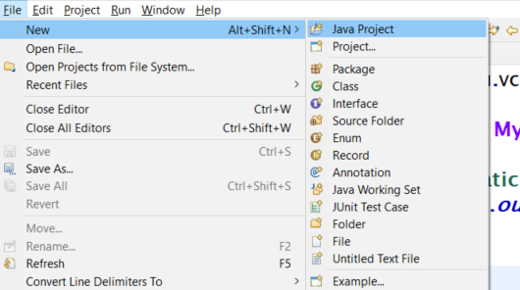

1. Please provide a valid name.
2. **Please do not create a module. Skip creating a module.**
3. Open the Git Repository view
   1. Window 🡪 Show View 🡪 Other
   2. Click on Git 🡪 Git Repositories

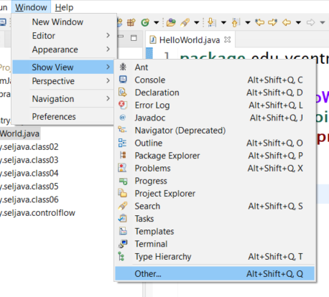

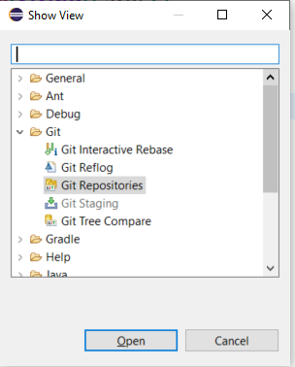

1. In the Git Repositories view, Choose a middle icon. Clone a git repo and add it to the view

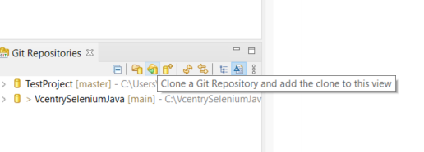

1. Go to git hub, click on the repository link or if the page is already open click on the copy icon (like a pad in the right)

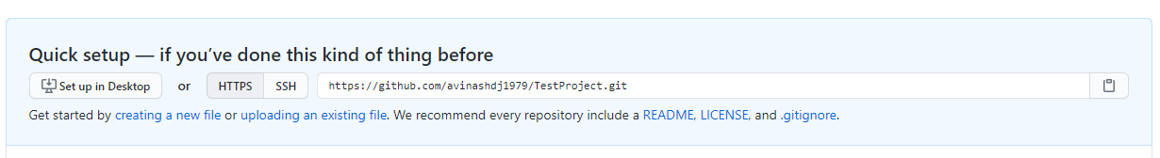

1. Otherwise click on Repository click on the code Green button and click on the pad like icon to copy the git repository link from the clone dialog. (ensure https is chosen)

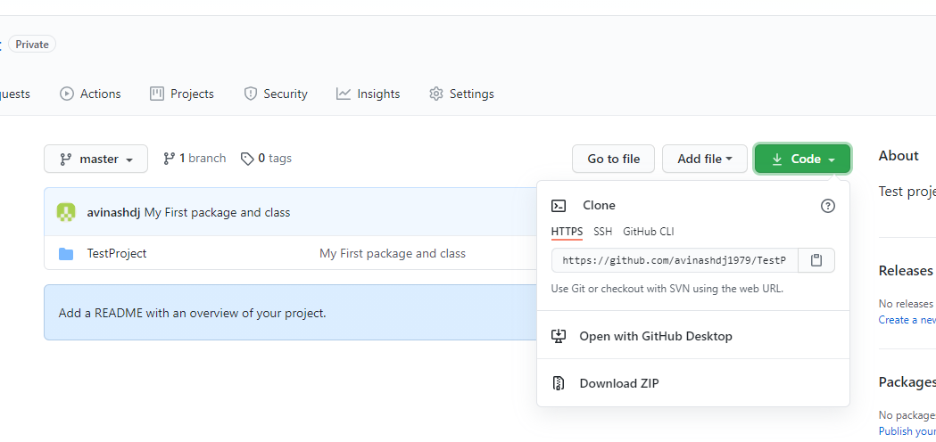

1. Come back to Eclipse, paste the value copied in step 10 or 11, to the URI field and enter the git credentials in username and password and click on Next.

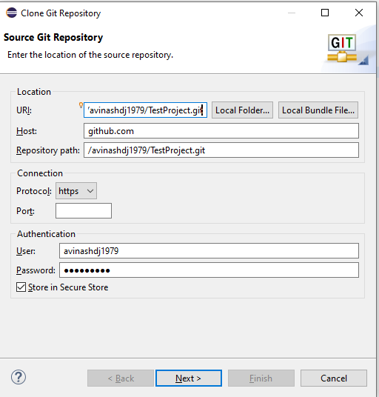

1. Please not down the directory where the git repo is cloned
2. Ensure that the project cloned shows up in the Git Repositories view.

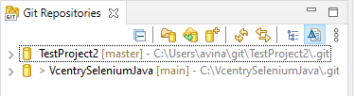

1. Right click on the Java Project created in eclipse, choose the Menu Team and Share Project.

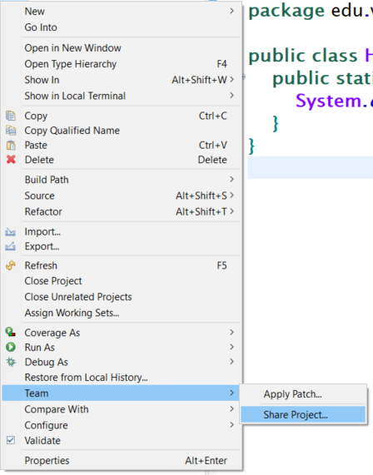

1. Choose the repo from the dialog Configure Repository.

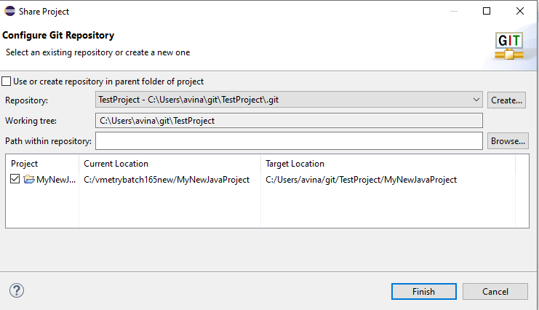

1. Click on Finish.
2. Now at this step the your project name in the eclipse should change and show up the branch in the Github repo. [main or master near your project name]

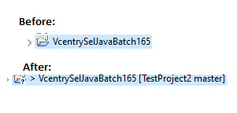

1. Right click on the Project,, Select Team menu and Click on Commit

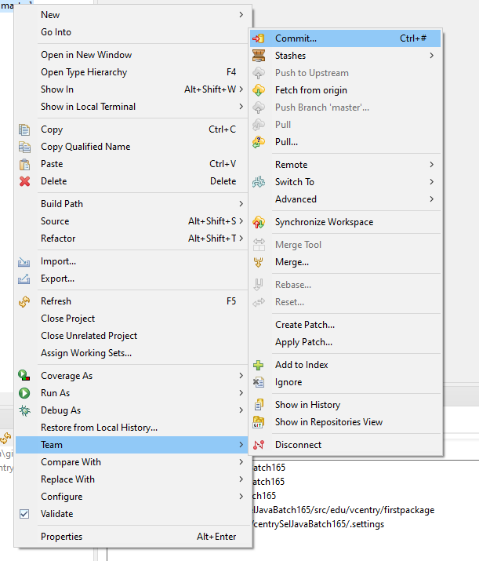

1. In the Git Staging dialog shown below, drag the changes from the Unstaged Changes(5) to Staged Changes box

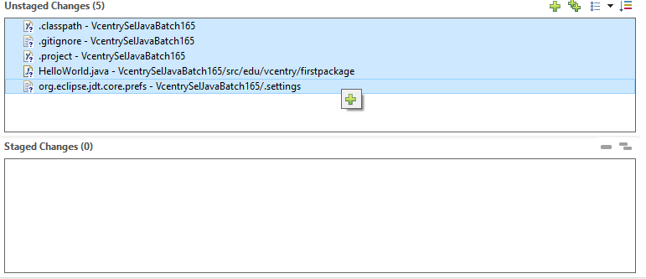

1. Select all and click on the + button (Add selected files to the index)
2. Enter the commit message
3. Click on Commit and Push button

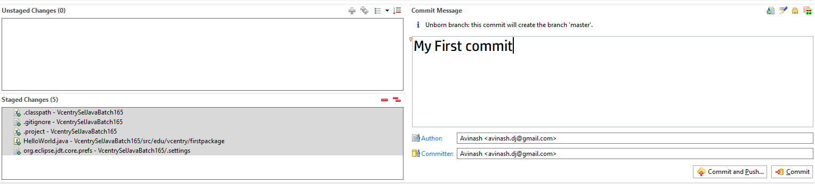

1. Click on Preview and Click on the Push button in the Push Confirmation dialog

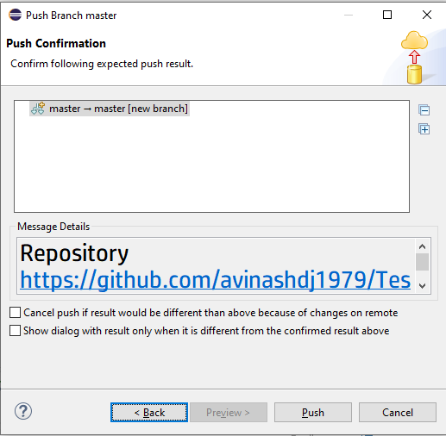

1. Message pushed to Project name should popup

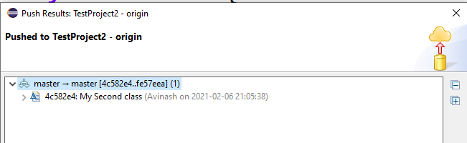

1. Do this every new file that is added.
2. **!!Happy Coding !! Happy Gitting !!**